1. **Agenda:**
   1. How one microservice can connect with another microservice using Eureka Registry Details and Netflix Feign client.
2. With Feign client, we can achieve the client side load balancing.
3. What we’re going to do?
   1. We will create one new end-point inside accounts microservice that would call other microservices (cards, loans) then the complete info (account, loan, card) would be sent to the caller and the caller will pass only account id.
   2. So, account microservice will interact with other microservices using feign client.
4. 
5. 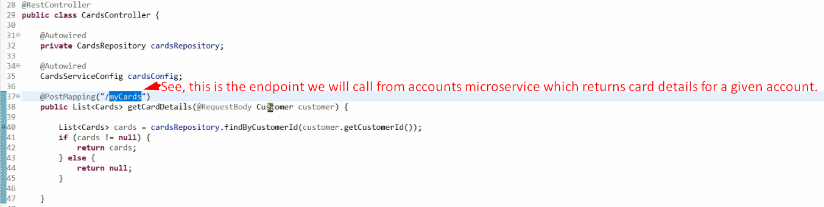
6. 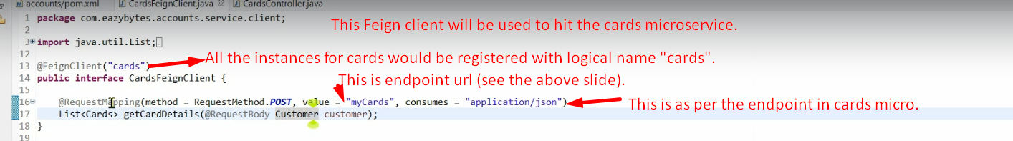
7. 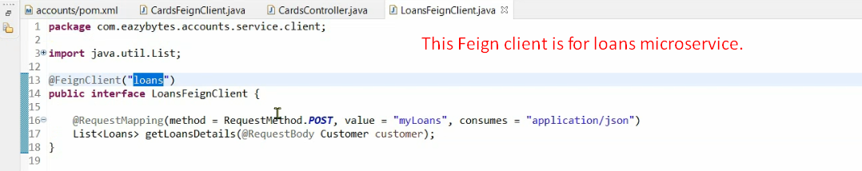
8. **NOTE**: Bean for Feign client is created automatically.
9. 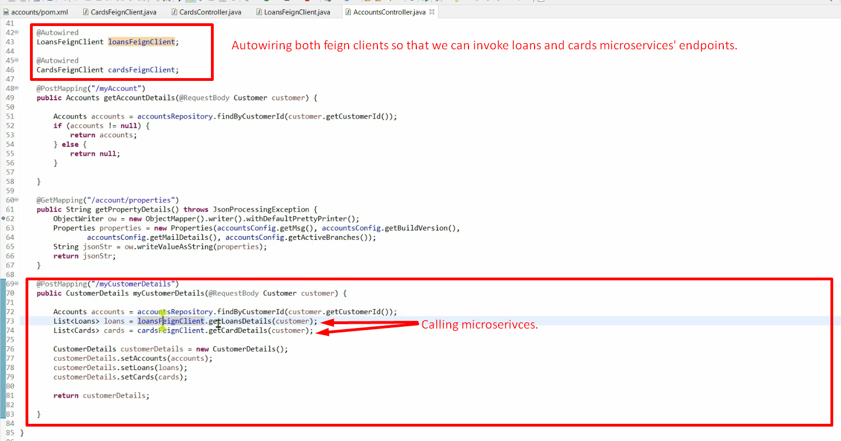
10. Remember, when first time feign client goes to Eureka Service Discovery, it will fetch the complete details about all registered instances for a microservices and cache them locally and does the load balancing based on this cached details.
11. Let’s demo.
12. First start Eureka Server then all the 3 microservices (accounts, loans, cards).
13. 